
RAMAIAH
Institute of Technology
USN | 1 | M | S

(Autonomous Institute, Affiliated to VTU)
(Approved by AICTE, New Delhi & Govt. of Karnataka) Accredited by NBA & NAAC with ‘A’ Grade

SEMESTER END EXAMINATIONS – JANUARY 2020

Program | : | B.E.: Electrical and Electronics Engineering | Semester | : | V
Course Name | : | Control Systems | Max. Marks | : | 100
Course Code | : | EE52 | Duration | : | 3 Hrs

Instructions to the Candidates:
- Answer one full question from each unit.
- Suitably assume any missing data.

 |  | UNIT- I
1. | a) | Find 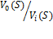 for the circuit shown in Fig.1(a). Assume gain of the buffer amplifier as 1.  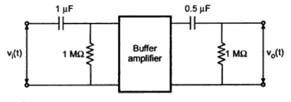  Fig.1(a) | CO1 | (10)
 | b) | Draw the equivalent mechanical system and analogous systems based on F-V and F-I methods for the system given in Fig. 1(b). Assume the displacements suitably.  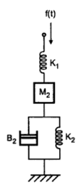  Fig.1(b) | CO1 | (10)
2. | a) | Draw the F-V and F-I analogous electrical networks for the Fig. 2(a). Assume the displacements suitably.  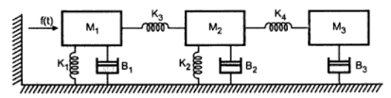  Fig. 2(a) | CO1 | (10)
 | b) | Derive transfer function of armature controlled separately excited DC servo motor. Consider position and voltage as output and input, respectively. | CO1 | (10)
 |  | UNIT- II
3. | a) | Find the transfer function C(S)/ R(S) for the block diagram shown in Fig. 3(a).  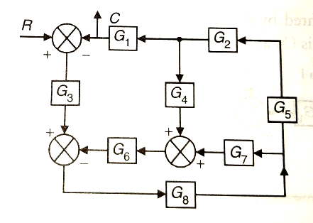  Fig. 3(a) | CO2 | (08)
 | b) | Find C(S)/ R(S) for the electrical circuit shown in Fig. 3(b) using Mason’s gain formula.  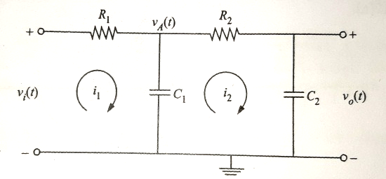  Fig.3(b) | CO2 | (08)
 | c) | A unity feedback system is characterized by the transfer function . Determine the value of K, so that the system will have a damping ratio of 0.5. | CO2 | (04)
4. | a) | A unity feedback system is characterized by the open loop transfer function . Determine the steady state error for unit step, unit ramp, and unit parabolic inputs. Also determine the damping factor and natural frequency of the dominant roots. | CO2 | (06)
 | b) | Find C(S)/ R(S) for the system shown in Fig.4(b) using Mason’s gain formula.  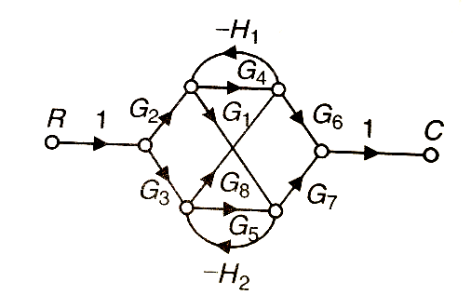  Fig. 4(b) | CO2 | (10)
 | c) | Find the transfer function C(S)/ R(S) for the block diagram shown in Fig.4(c).  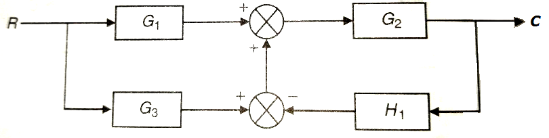  Fig.4(c) | CO2 | (04)
 |  | UNIT- III
5. | a) | State and explain RH criterion of stability. What are its limitations? | CO3 | (08)
 | b) | Plot the root locus of the system with OLTF 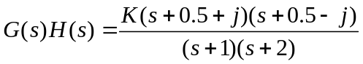, Show that part of root locus of system is a circle. | CO3 | (12)
6. | a) | State the steps of construction of root-locus from OLTF. | CO3 | (10)
 | b) | Plot the root locus for the system given by 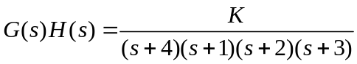. Comment on stability. | CO3 | (10)
 |  | UNIT- IV
7. | a) | Using standard notations for a typical second order system, derive the expression for i) Resonant Peak ii) and Bandwidth. Hence mention the relation between time domain and frequency domain specifications. | CO4 | (08)
 | b) | Using Nyquist stability criterion, investigate the stability of closed loop system whose OLTF is 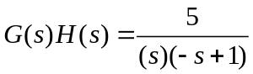. | CO4 | (12)
8. | a) | A unit step input is applied to unity negative feedback system having OLTF 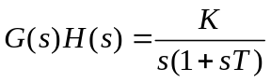.  Determine K and T to have peak overshoot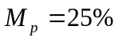 and resonant frequency 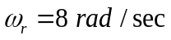. Also find resonant peak 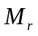 | CO4 | (10)
 | b) | Using Nyquist stability criterion, investigate the stability of closed loop system whose OLTF is 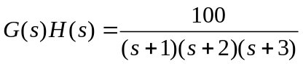. | CO4 | (10)
 |  | UNIT- V
9. | a) | Obtain the transfer function of lag compensator, for 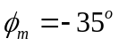and 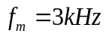. Assume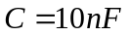. Also find the corner frequencies. | CO5 | (10)
 | b) | Obtain the transfer function of the system whose Bode plot is as shown below.  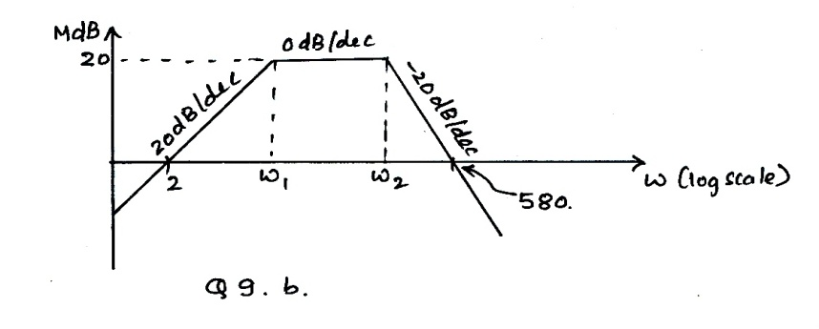  Fig. 9(b) | CO4 | (10)
10. | a) | Define i) Gain Margin ii) Phase margin of a system. Hence mention the conditions for stability of a system. | CO4 | (08)
 | b) | Obtain the transfer function of the system whose Bode plot is as shown below.  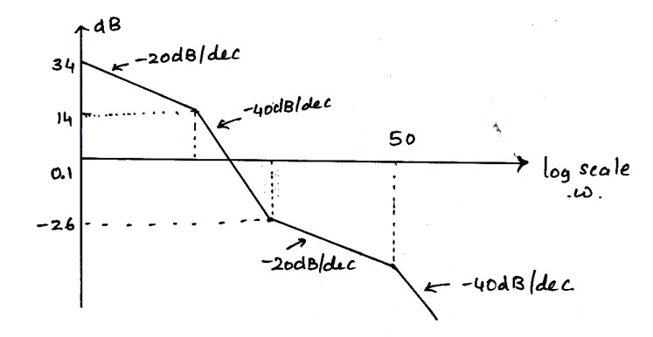  Fig. 9(c) | CO4 | (06)
 | c) | What is the difference between a lag and a lead compensator? | CO4 | (06)

****************

